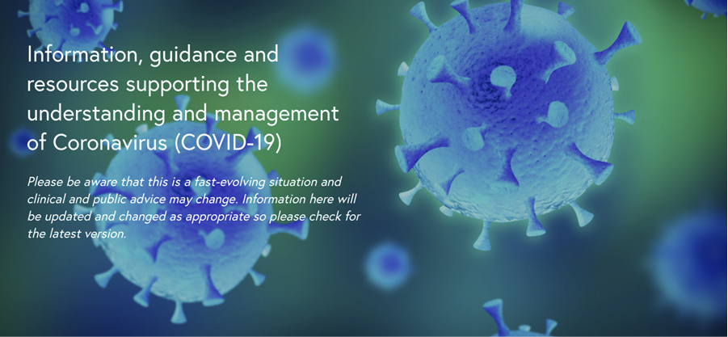

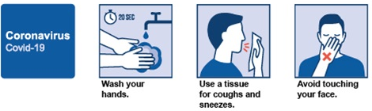

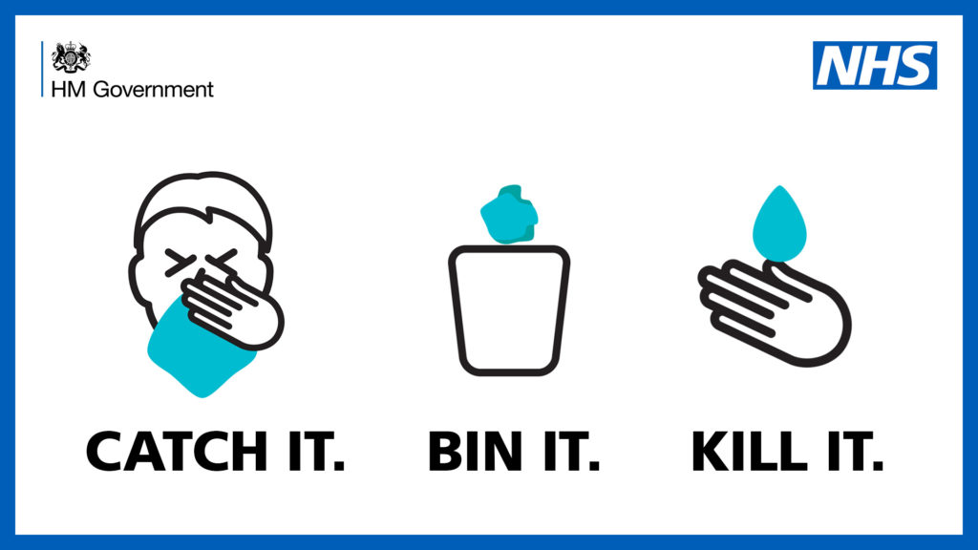
Activity | Persons At Risk |  |  | Reference No: |  |  |  |  | Date: |  |  |  |  |  | Assessed By:
 | Employees |  | Contractors |  |  | Visitors/Public |  |  |  |  |  | Other Disabled/Young/Expectant Mothers etc..(*delete as appropriate)
 | Hazard identified |  |  |  |  |  | Severity  1-5 | Likelihood  1-5 |  | Risk Factor |  |  |  |  |  | Additional Controls/Recommendations |  |  | Residual Risk
 |  |  |  |  |  |  |  |  |  | L  (1-6) |  |  | M  (8-16) | H  (16+)
Traveling to & from place of work | Contact with virus  Contamination of employees & further spread of the virus from surfaces and air contamination |  |  |  |  |  | 4 | 5 |  |  |  |  |  | 20 |  | - Avoid using public transport  - Use personal or company transport  - Comply with social distancing - staying 2 metres (6ft) apart from other people |  |  | 4 (4X1)
Access & egress | Contact with virus  Contamination of employees & further spread of the virus from surfaces and air contamination |  |  |  |  |  | 4 | 5 |  |  |  |  |  | 20 |  | Avoid using hand to open door use forearm or elbow (if possible) to open doors.  Provide non-contact alcohol-based sanitiser dispenser all staff & visitors to use immediately on entry to the building |  |  | 4 (4X1)
Personal Hygiene | Spread of virus  Further spread of the virus from surfaces and air contamination |  |  |  |  |  | 4 | 3 |  |  |  |  | 12 |  |  | - Use hand Sanitisers and hand washing facilities  - Avoid touching the face  - Cough or sneeze into bent elbow |  |  | 4 (4X1)
General surfaces | Contact with virus  Contamination of employees & further spread of the virus from surfaces and air contamination |  |  |  |  |  | 4 | 3 |  |  |  |  | 12 |  |  | - Keep all places of work clean and tidy  - Regularly clean with sanitiser (min 70% alcohol based) in case washing facilities are not readily available |  |  | 4 (4X1)
Working in close proximity to others | Contact with virus  Contamination of employees & further spread of the virus from surfaces and air contamination |  |  |  |  |  | 4 | 3 |  |  |  |  | 12 |  |  | - Keep safe distance form others 2 metres (6ft) apart)  - Wash hands on a regular basis if not available use hand sanitiser  - Review work schedules including start & finish times/shift pattern to reduce number of workers on site at any one time.  - Consider relocating workers to other tasks.  https://www.hse.gov.uk/news/coronavirus.htm  https://www.publichealth.hscni.net/news/covid-19-coronavirus  https://www.gov.uk/government/publications/covid-19-guidance-on-social-distancing-and-for-vulnerable-people |  |  | 4 (4X1)

 | Hazard identified | Severity  1-5 | Likelihood  1-5 | Risk Factor |  |  | Additional Controls/Recommendations | Residual Risk
 |  |  |  | L  (1-6) | M  (8-16) | H  (16+)
Working in close proximity to others | Contact with virus  Contamination of employees & further spread of the virus from surfaces and air contamination | 4 | 3 |  | 12 |  | - Redesign workplaces and processes to reduce people movement and ensure social distancing in place.  - Conference calls to be used instead of face to face meetings.  - If possible avoid using or sharing equipment & tools | 4 (4X1)
Working in close proximity to others | Movement around sites during breaks | 4 | 3 |  | 12 |  | - Ensuring sufficient rest breaks for staff.  - Stagger breaks to reduce numbers  - Social distancing to be adhered to in canteen & smoking areas. | 4 (4X1)
Mental health | Some people may be prone to increased stress levels due to social isolation and worry over the virus affecting them and loved ones | 4 | 2 |  | 8 |  | - Consider undertaking a separate individual stress assessment  https://www.mind.org.uk/information-support/coronavirus-and-your-wellbeing/ | 4 (4X1)
Communal areas such as kitchens | Contact with virus  Contamination of employees & further spread of the virus from surfaces and air contamination | 4 | 5 |  |  | 20 | Limit access to one person at a time  Provide sanitising wipes to wipe down surfaces and handles prior to use (microwaves / kettles etc)  Provide non-contact alcohol-based sanitiser dispenser all staff & visitors to use  Allocate 1 person to tea & coffee making each day (where possible) staff to use sterile alcohol-based wipes to wipe handles of cups prior to drinking | 4 (4X1)
Toilet facilities | Contact with virus  Contamination of employees & further spread of the virus from surfaces and air contamination | 4 | 5 |  |  | 20 | Provide non-contact alcohol-based sanitiser dispenser all staff & visitors to use immediately on entry to the building | 4 (4X1)
Workplace layout |  | 4 | 5 |  |  | 20 | Provide non-contact alcohol-based sanitiser dispenser all staff & visitors to use  Provide all staff with their own alcohol based wipes to clean surfaces | 4 (4X1)

 | Hazard identified | Severity  1-5 | Likelihood  1-5 | Risk Factor |  |  | Additional Controls/Recommendations | Residual Risk
 |  |  |  | L  (1-6) | M  (8-16) | H  (16+)
Selection & Use of PPE | Inappropriate PPE or worn incorrectly can lead to increased exposure to the virus. Main routes of entry are:  - The mouth (breathing and touching)  - Nose (breathing and touching)  - Eyes (splashes / droplets from sneezes / coughing)  Public Health guidance on the use of PPE (personal protective equipment) to protect against COVID-19 relates to health care settings. In all other settings individuals are asked to observe social distancing measures and practice good hand hygiene behaviours. | 4 | 5 |  |  | 20 | PPE is usually a last resort after all other measures have been exhausted. Social distancing should always be maintained where ever possible as the main protection.  https://www.hse.gov.uk/news/face-mask-ppe-rpe-coronavirus.htm | 4 (4X1)
Gloves |  | 4 | 5 |  |  | 20 | Although the current guidance from Public Health England advises that gloves are not recommended as a protective measure they should be made available:  Rubber, nitrile or latex gloves can offer a level of protection as long as they are used correctly  - Wash or sanitise hands before fitting gloves  - Dispose of by removing and turning inside out  - Wash or sanitise hands immediately after removal  - Do not touch your face or any other part of your body until you have washed or sanitised your hands  - Check user(s) do not have an allergy to latex before supplying gloves | 4 (4X1)

 | Hazard identified | Severity  1-5 | Likelihood  1-5 | Risk Factor |  |  | Additional Controls/Recommendations | Residual Risk
 |  |  |  | L  (1-6) | M  (8-16) | H  (16+)
Face masks | Type N95 and FFP2 masks are recommended | 4 | 5 |  |  | 20 | Wash or sanitise hands before fitting mask:  - Ensure mask is a tight fit around nose and mouth (if not a good fit then it may be ineffective)  - Pieces that cannot be adequately disinfected (e.g. disposable half masks) should not be used by more than one individual. | 4 (4X1)
Eye protection | Ideally full-face visors should be worn where this is not possible or practical tight-fitting safety glasses should be worn | 4 | 5 |  |  | 20 |  | 4 (4X1)

ADDITIONAL GUIDANCE
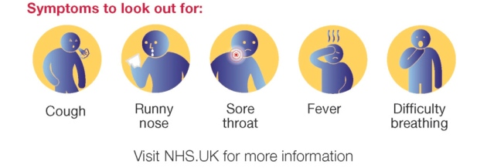

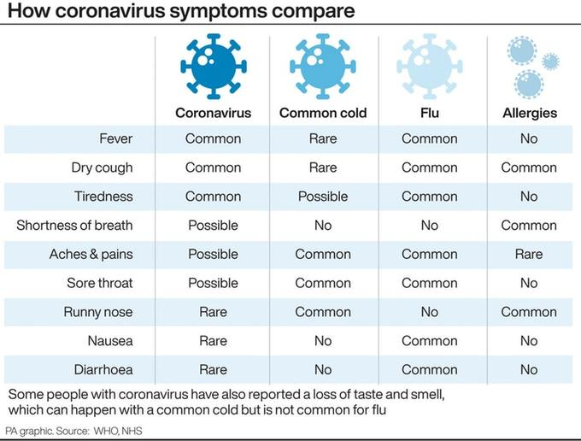

Spread of virus:
Note: Symptoms can be mild, moderate, severe or fatal. You can be infected with the virus and show no symptoms, you can also be contagious without symptoms and can spread the virus without knowing.

The most common symptoms of COVID-19 are fever, tiredness, and dry cough. Some patients may have aches and pains, nasal congestion, runny nose, sore throat or diarrhea. These symptoms are usually mild and begin gradually. Some people become infected but don’t develop any symptoms and don't feel unwell. Most people (about 80%) recover from the disease without needing special treatment. Around 1 out of every 6 people who gets COVID-19 becomes seriously ill and develops difficulty breathing. Older people, and those with underlying medical problems like high blood pressure, heart problems or diabetes, are more likely to develop serious illness. People with fever, cough and difficulty breathing should seek medical attention.
Hand Washing:
- Wash hands regularly with soap and hot water.
- Wash hands for at least 20 seconds
- Stringent hand washing taking place.
- Use hand dyers / disposable paper towels for drying hands
- See hand washing guidance. https://www.nhs.uk/live-well/healthy-body/best-way-to-wash-your-hands
Carry gel sanitiser (min 70% alcohol based) in case washing facilities are not readily available
Cleaning:
Frequently cleaning and disinfecting objects and surfaces that are touched regularly particularly in areas of high use such as door handles, light switches, reception area using appropriate cleaning products and methods. Use sanitiser (min 70% alcohol based)

Social Distancing:
Social Distancing -Reducing the number of persons in any work area to comply with the 2-metre (6.5 foot) gap recommended by the Public Health Agency
https://www.publichealth.hscni.net/news/covid-19-coronavirus

TRAINING COURSES
We provide a wide range of accredited classroom based and eLearning Courses

INFECTION CONTROLLED

Accreditation:
The content of this course has been independently certified as conforming to universally accepted Continuous Professional Development (CPD) guidelines and offers 1 hour of CDP credit
Certification:
On successful completion of this course you will be able to print your own CDP accredited certificate via your courses home page…

Course Content:
Includes multiple-choice test and skill check questions throughout the course, this is a comprehensive and fully interactive training course, suitable for NHS use and other healthcare sectors.
- Introduction to infection control
- MRSA
- Hand washing
- Isolation
- Needles and sharps
- Hygiene and cleaning
- Infection Control was developed with a number of senior key staff from within the NHS.

Therefore, we feel confident that the information covered is relevant and specific for your needs, whether you are looking for induction training for Infection Control, or refresher training for Infection Control, this module will help

STRESS MANAGEMENT

Accreditation:
The content of this course has been independently certified as conforming to universally accepted Continuous Professional Development (CPD) guidelines and offers 1 hour of CDP credit
Certification:
On successful completion of this course you will be able to print your own CDP accredited certificate via your courses home page…

Course Content:
Explains why managing organisational stress is important and the legal position. Also defines 'stress', distinguishing it from acceptable levels of pressure.

It is well recognised that stress reduces employee well-being, and that excessive or sustained work pressure can lead to stress. Occupational stress poses a risk to most businesses and compensation payments for stress-related injuries are rising.
It is important to meet the challenge by dealing with excessive and long-term causes of stress. This interactive training module will explain all the key issues relating to 'stress in the workplace' and how to avoid it. Complete with interactive 'missions'.

RISK MANAGEMENT

Accreditation:
The content of this course has been independently certified as conforming to universally accepted Continuous Professional Development (CPD) guidelines and offers 1 hour of CDP credit
Certification:
On successful completion of this course you will be able to print your own CDP accredited certificate via your courses home page…

Course Content:
This CDP module is a course ideal for anyone wishing to gain an introduction to the subject of health and safety risk assessment. Employees in any sector will find a working knowledge of health and safety issues to be a valuable resource for themselves and their organisations. This training will encourage employees to be proactive about risk assessment, in order to prevent accidents and ill health.
Risk management involves you, the employer, looking at the risks that arise in the workplace and then putting sensible health and safety measures in place to control them. By doing this you can protect your most valuable asset, your employees, as well as members of the public from harm. During 2004/05, 220 people were killed and over 150,000 were injured at work because of a failure to manage risk.
As an employer, the law requires you to assess and manage health and safety risks - for most businesses this is not difficult to do, you should adopt the Five Steps to Risk Assessment approach to help you. This is not the only way to do a risk assessment, there are other methods that work well, particularly for more complex risks and circumstances. However HSE believe this method is the most straightforward for most organisations - source HSE.
On completion of this training you will be able to:
- Define the meaning of the terms hazard, risk and risk assessment
- Describe the legal requirements for risk assessment
- Identify hazards and those who may be harmed
- Describe the processes for the evaluation and control of risks
- Describe the systems used to record, review and revise risk assessments

For a full list of training offered by RKMS please visit:

https://www.rkmsuk.co.uk

